A256-Afr-Egy-Ushabti-New Kingdom-19th Dynasty-1293-1189 BCE-Blue Faience

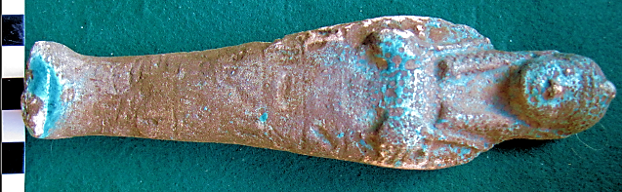

**Case No.: 2**

**Formal Label:** Ushabti-New Kingdom-19th Dynasty-1293-1189 BCE

**Display Description: New Kingdom composite duplex wig, upper part striated, lower part with undulating striations. Seven registers of hieroglyphics.**

**Accession Number: 256**

DT62

**Date or Time Horizon:** New Kingdom, 19th dynasty-1293-1189 BCE

**Geographical Area:**

**Map, GPS Coordinates**: 24.933333, 32.833333; 24° 56' 00" N, 32° 50' 00" E.

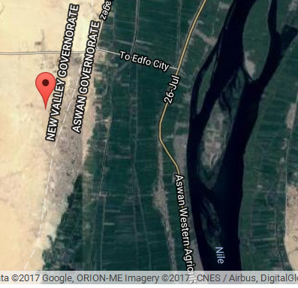

**Cultural Affiliation:** New Kingdom, 19th dynasty-1293-1189 BCE

**Medium:** blue faience

**Dimensions: 170.59 mm; 6.77 in  
Weight: 130 gm; 4.5 oz**

**Provenance: unknown**

**Condition:** original

**Discussion:** Enormous social upheavals had been caused by Akhenaten's religious reform so that Seti I re-established stability and reasserted Egypt's sovereignty over Canaan and Syria, which had been under threat from the Hittites, which he confronted but failed to eliminate as a threat but` he reconquered most of the disputed territories with military successes. His funerary temple was constructed in Qurna on the west bank of the Nile at Thebes and his capital was at Memphis.

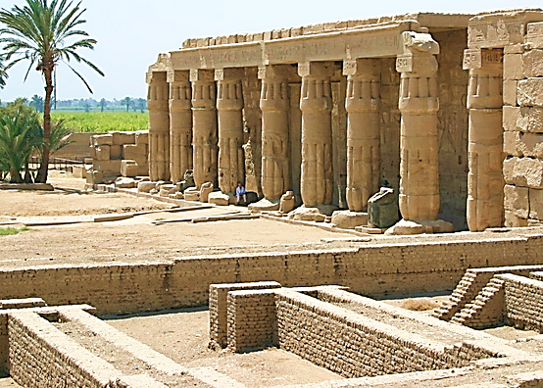

Fig. 2. Mortuary Temple of Seti I at Qurna, on the west bank of the Nile at Thebes. After https://upload.wikimedia.org/wikipedia/commons/6/6a/Seti_I_Temple_at_Qurna.jpg

**References:**

Aubert, J.-F. et L. Aubert. 1974. *Statuettes Egyptiennes: Chaouabtis, Ouchebtis.* Paris, 1974.

Janes, Glenn. 2002. *Shabtis. A Private View, Ancient Egyptian Funerary Statuettes in European Private Collections.* Paris: Cybèle.

Newberry, Percy E. 1930-1957. *Funerary Statuettes and Model Sarcophagi.*  Le Caire: Impr. de l'Institut français d'archéologie orientale.

Schneider, Hans D. 1977. *Shabtis - An Introduction to the History of Ancient Egyptian Funerary Statuettes. With a Catalogue of the Collection of Shabtis in the National Museum of Leiden*. (3 volumes, Leiden: Rijksmuseum van Oudheden Te Leiden.

Schlögl, Hermann and Andreas Brodbeck. 1990. *Ägyptische Totenfiguren aus öffentlichen und privaten Sammlungen der Schweiz.* Orbis Biblicus et Orientalis, Series Archeologica, 7. Göttingen, Vandenhoeck & Ruprecht; Freiburg Schweiz, Universitätsverlag.